**Sharing the Good News of Christmas – The Three Circles**

Christmas is about the coming of the Messiah. But why did Jesus come? The Bible, of course, answers this all-important question. We want to introduce you to a simple, adaptable model that is helping us effectively share with others the big idea of the Bible, centering around the glorious news that Jesus has come to rescue all who would put their trust in Him.

Here’s a simple roadmap, and you can readily learn to sketch this out on the fly – like on a napkin in a café!

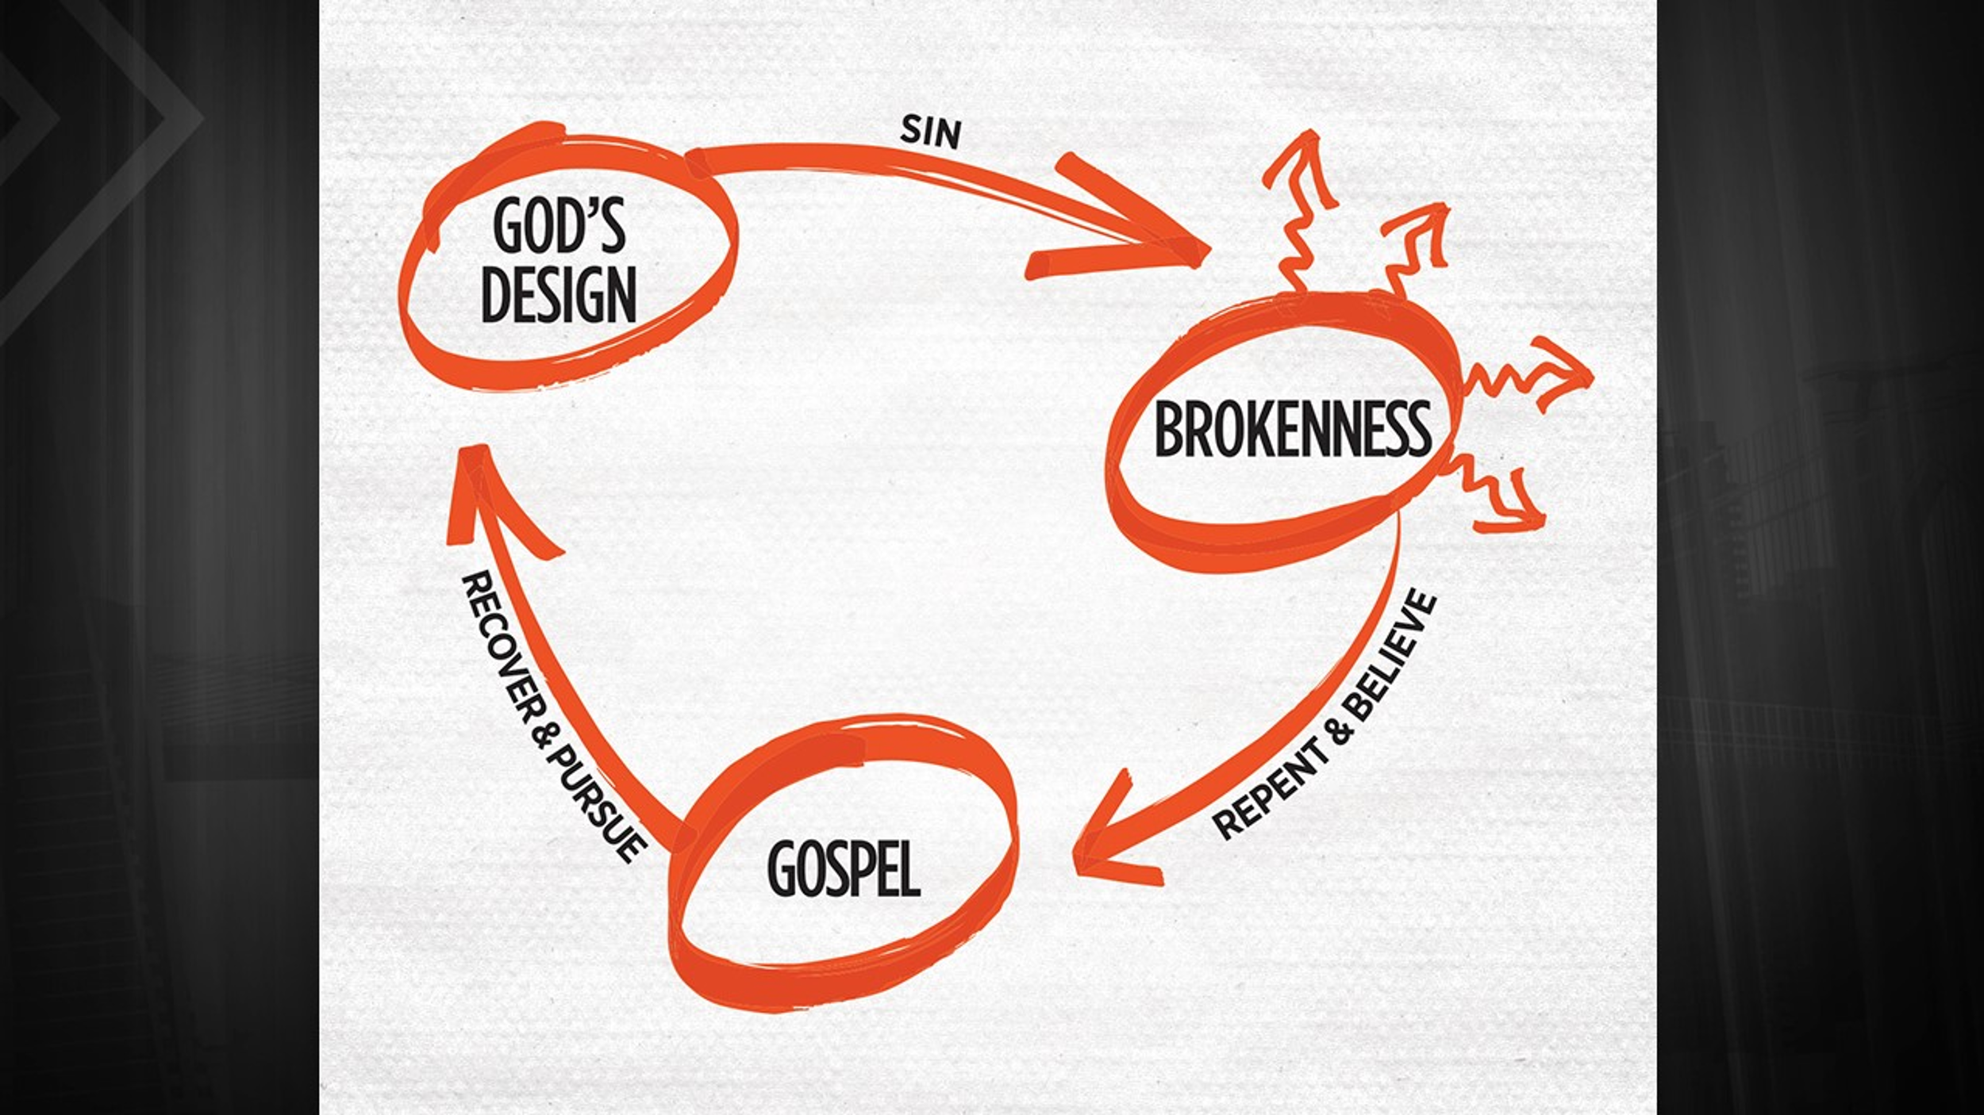

And here’s what you might say (feel free to adapt and personalize). The sketch above provides the outline, and you can simply use your own words to talk through the big idea of the Bible using the Three Circles sketch:

**God’s Design**: God created the world, and He created humans in His image. We were created to be in relationship with God, to know Him, to walk with Him, and to flourish under His rule and reign. We were created to live forever with God, and in God we had everything we needed. There was a condition, however. God said if we fail to honor Him as absolute ruler and rebelled against Him, then we would fall under the curse of death and would be expelled from God’s presence.

**Sin and Brokenness**: This rebellion against God is called sin. Essentially, sin means that we rejected God as King of our lives and have chosen to do life our own way. As humans, our sin brought on decay, death, and brokenness. Apart from God, we find ourselves trapped in brokenness. We can see this readily when we look at the world. People mistreat one another. There is sickness and disease. The suffering of humanity is incalculable. All this is the brokenness created by our own sin. we humans somehow seem to know that we were made for something more. Thus, we try many different ways to escape the brokenness. Some try alcohol and drugs. Some try relationships and sexual promiscuity. Some try to make enough money to buy their way out of the brokenness. Some even try being religious and striving to becoming better people. However, none of this allows us to escape the brokenness. Instead, like bungee cords, they just snap us right back into even more brokenness. There’s no way out – UNLESS God provides the escape route.

**Repent and Believe the Gospel (Good News)**: There is good news! God has provided a way out of the brokenness. As the ultimate act of love, He sent Jesus, His Son, to rescue those who would believe and surrender. Jesus came from heaven to earth and lived a perfect, sinless life. Bearing the sin of those who would believe, Jesus died on the cross and paid the debt for their sins. He rose from the dead, defeating sin and death forever. The Bible says that our sins will be forgiven, we’ll be rescued from brokenness, and we’ll be restored to God’s original design if we do two things. First, we must repent of our sins. This means turning away from doing life our way (sinful rebellion) and committing to live God’s way (surrendering to Jesus as King and Lord). Second, we must believe that Jesus is the Son of God, that He died for our sins, that He rose again, and that He’s coming again to take us to be where He is.

**Freed to Recover and Pursue God’s Design**: When we repent of our sins and put our trust in Jesus, then our sins are wiped away, and we are finally free to pursue God’s design for our lives, to flourish under His rule and reign, to walk closely with Him, and to live fully for His glory. Moreover, our lives take on new purpose, as God sends us back into the broken world to share with others the big idea of the Bible and how Jesus came to rescue those who would believe.   
 ***Will you surrender your life to Jesus now? Would you like to learn more? Let’s read the Bible together!***

**Initiate Gospel Conversations with Your Family**

While you can always interject the Three Circles as doors open in casual conversations, family Christmas gatherings can provide easy opportunities for more intentional discussions about Jesus and why he was born. Use the Three Circles guide on the reverse to talk through the big idea of the Bible with family and friends at your Christmas get-togethers!

Want to take it up a notch? After sharing the Three Circles, invite those interested into a Bible study with you. If you don’t live near one another, make it a regular video/phone call. If you’re a parent, this is a great way to initiate regular family Bible study. Below, we will share some tips for getting started.

**Launching a Bible Study with Family and Friends**

**Selecting Biblical Texts for Your Study**

Every circumstance is different, and you’ll want to prayerfully and thoughtfully choose passages for your study. You can choose texts focused on a particular topic, such as blood sacrifice, or you might work through an entire book of the Bible. The Gospel of John is always a good place to start!

This site (<https://www.dbsguide.org/additional-studies/>) has numerous reading/study plans designed for different circumstances, such as one for new believers, another for seekers, and so on. On a personal note, when our children were younger, we led them through the 28-passage overview of the Bible found on the site, and it gave our kids a great foundation in the Bible.

**Facilitating Discussion Around the Text**

As facilitator, you’ll want to allow lots of space for others to talk and share. The questions/steps below will guide you in facilitating the discussion. Also, you can decide how frequently you will have Bible study and how much text you will cover each time. I recommend higher frequency and shorter passages (maybe 10-15 verses each time).

1. **Review the previous passage and our response to it**. Paraphrase in summary form what we read in the previous meeting. Was there anything you tried to change, stop, or start in response to the passage? How did it go? Did you get to share it with anyone?
2. **Read the new passage aloud and do so more than once if necessary to take it all in**.
3. **Paraphrase and summarize.** This is just simply retelling the story or passage in our own words. Someone starts the summary, and the rest of us jump in with additions and/or corrections. Corrections are important, because we want to make sure that we are accurately reflecting what the passage says.
4. **Core questions.** With each question, take turns offering insights from the text that fit within the parameters of the given question.
   1. **What does this reveal about the Triune God and His plan?**
   2. **What does this reveal about mankind?**
   3. **How can we obey what God tells us in this passage?**
   4. **With whom can you share this story/teaching/lesson?**   
      (Encourage kids to share with grandparents, aunts, etc. This will probably bless the socks off your relative, and it will get your kids in the habit of talking about the Bible and their faith.)
5. **Prayer.** The facilitator opens the floor for anyone who wants to pray out loud. After several people have prayed or some time has passed, the facilitator will close the meeting in prayer. We always try to pray in response to the passage, asking God to help us live out what we just studied. Also, we ask God to give us opportunities to share this passage with others (often in casual conversations). We can share it with other believers as a way to encourage them, and we can share it with unbelievers as a way to point them toward Jesus and the Bible.

**To ask questions and to request more tools/resources, please contact Thomas and Carrie Davis at tdavis1520@gmail.com.**